* 1. y = + ax + bx^2 + cx^3 + dx^4 + E
     + 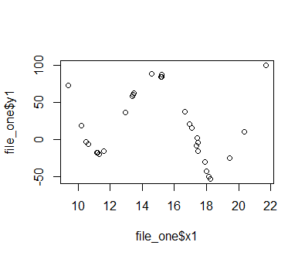
     + 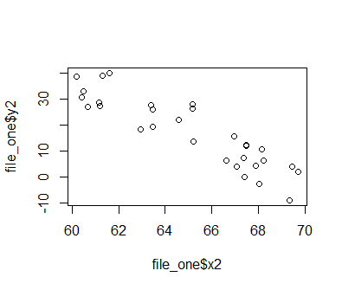
     + y = x^1/2 maybe y = -bx^2
     + 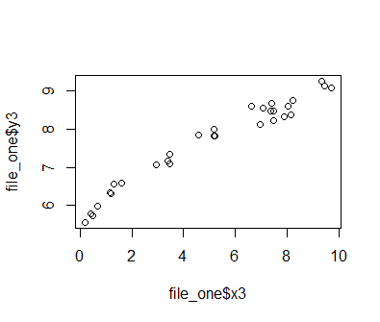

1. Refer to document
   * + y^ = ^b0+^b1(x) + E
       1. 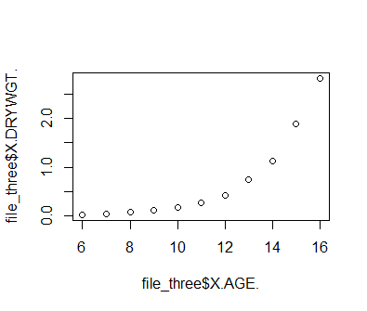
     + z^ = ^b0+^b1X + E
       1. 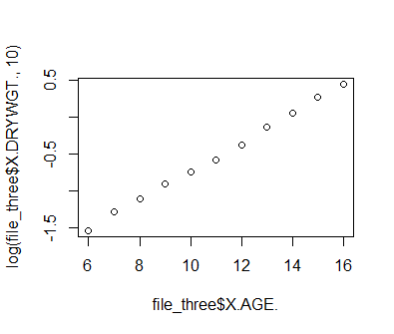
     + Dry weight vs age is exponential , and log(dry weight) vs age is linear
   1. (Intercept) file_three$X.AGE.
      * -1.8845273 0.2350727
      * y.hat = -1.8845 + .2351x
        + 1. z.hat
        1. (Intercept) file_three$X.AGE.
        2. -2.6891985 0.2350727
      * z.hat = -2.6892 + .2351x
   2. > SSE.y
      * [1] 2.089602
        + 1. SSE.z
      * [1] 0.007054059
   3. As the age increase by one unit (presumably year), the dry weight will increase by .2351, and the log dry weight increases by .2351
      * #e 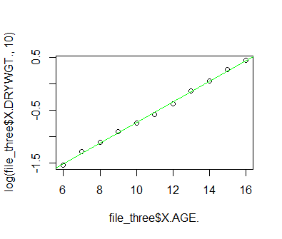
      * 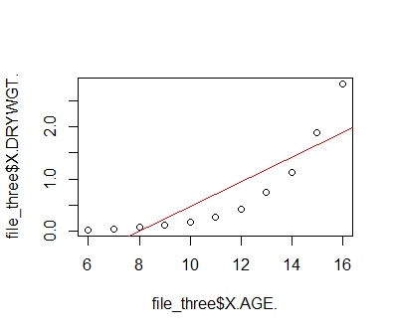
2. 4.
   1. No the data looks like a logistic function
      * 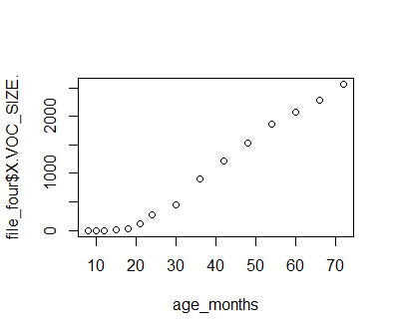
   2. The model looks like it could be y^ = b0^ + b1^(L/(1+exp(-kx)) + E, but if linear it would be y^ = b0^ + b1^x
   3. y = -621.126 + 43.893*x, b0^ = -621.126, b1^ = 43.893
   4. No it does not, there is no such thing as a negative memory/knowledge of words
   5. 15180.35 about 15181 words would a 30 year old individual know
   6. 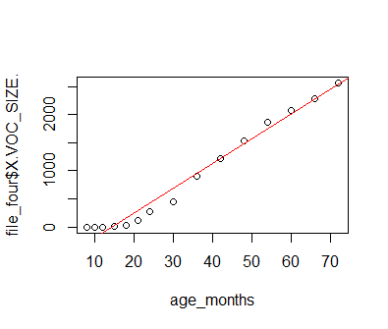
   7. No
      * 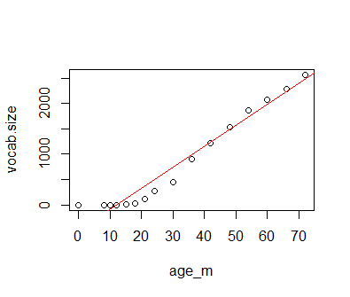
   8. 20.000 words known for a 30 year old, yes
   9. 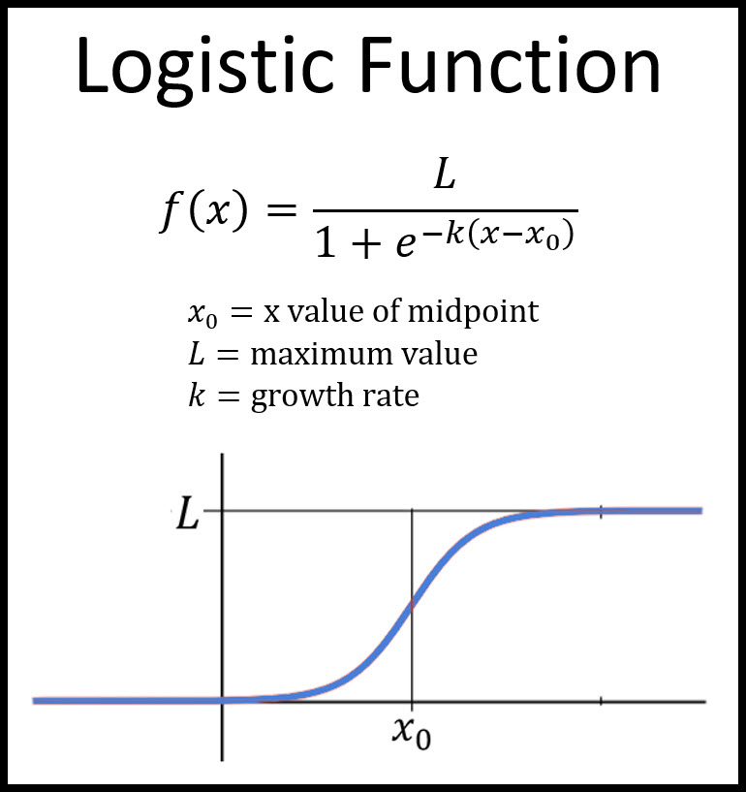
      * Where L = about 30,000 and X0 = maybe 15
   10. Sample mean of x = 2.5, sample mean of y = 10.6
   11. B1^ = 1163987, b0^ = 301.597
   12. SSE= -6531.149, S^2(y|x) = -362.84

Code:

#1

#y = b0 + ax + bx^2 + cx^3 + dx^4

file_one = read.csv("C:\\Users\\danie\\Documents\\School\\Math\\Stat 308\\Hw\\question1.txt", header = T)

colnames(file_one) #Prints column names

#a

#plot(file_one$"y1"~file_one$"x1") #y = bx^4 + c

#b

#plot(file_one$"y2"~file_one$"x2") #y = bx + c

#c

plot(file_one$"y3"~file_one$"x3")

#3

file_three = read.csv("C:\\Users\\danie\\Documents\\School\\Math\\Stat 308\\Hw\\ch05q01.txt", header = T)

colnames(file_three)

#a

#plot(file_three$"X.DRYWGT."~file_three$"X.AGE.")

plot(log(file_three$"X.DRYWGT.", 10)~file_three$"X.AGE.")

#b Regression line

fit.y = lm(file_three$"X.DRYWGT."~file_three$"X.AGE.") #Fits linear model

fit.z = lm(log(file_three$"X.DRYWGT.", 10)~file_three$"X.AGE.") #Fits linear model

summary(fit.y)

summary(fit.z)

slope.y = fit.y$coefficients[2]

slope.z = fit.z$coefficients[2]

intercept.y = fit.y$coefficients[1]

intercept.z = fit.z$coefficients[1]

#y.hat = intercept.y + slope.y*x

#z.hat = intercept.z + slope.y*x

y.hat = c(intercept.y, slope.y)

z.hat = c(intercept.z, slope.y)

y.hat

z.hat

#c Calc SSE

SSE.y = sum(fit.y$residuals^2)

SSE.z = sum(fit.z$residuals^2)

SSE.y

SSE.z

#d

plot(file_three$"X.DRYWGT."~file_three$"X.AGE.")

abline(fit.y, col = 'red')

plot(log(file_three$"X.DRYWGT.", 10)~file_three$"X.AGE.")

abline(fit.z, col = 'green')

#4

file_four = read.csv("C:\\Users\\danie\\Documents\\School\\Math\\Stat 308\\Hw\\ch05q12.txt", header = T)

colnames(file_four) #Prints column names

#a

age_months = c(12*file_four$"X.YEARS."+file_four$"X.MONTHS.")

age_months

#b

fit.voc = lm(file_four$"X.VOC_SIZE."~age_months) #Fits linear model

summary(fit.voc)

slope.voc = fit.voc$coefficients[2]

intercept.voc = fit.voc$coefficients[1]

print(c(intercept.voc, slope.voc))

SSE.voc = sum(fit.voc$residuals^2)

print(SSE.voc)

#e

x = 30*12

y.vocab_hat = -621.126 + 43.893*x

(y.vocab_hat)

#f

plot(file_four$"X.VOC_SIZE."~age_months)

abline(fit.voc, col = 'red')

#g

#?append

vocab.size = c(0, file_four$"X.VOC_SIZE.")

age_m = c(0, age_months)

print(vocab.size)

print(age_m)

fit.new = lm(vocab.size~age_m)

slope = fit.new$coefficients[2]

int = fit.new$coefficients[1]

plot(vocab.size~age_m)

abline(fit.new, col = 'red')